The Welsh Rhino is a challenge walk that traverses the remote and rugged Rhinogyd range in Snowdonia, North Wales, taking in the peaks of Diffwys, Y Llethyr, Rhinog Fach and Rhinog Fawr. The starting point for the walk is Barmouth station and ends at The Victoria Inn, Llanbedr.
Depending on choice of route, the walk is approximately a minimum of 19 miles in length and the challenge is to complete the walk in less than 12 hours.
However there are two restrictions on how the walk is undertaken:
1 Groups of a maximum of six people to attempt the walk at one time.
2 The ascent of Rhinog Fawr (or descent if walking from North to South) is completed using the waymarked footpaths in the Forestry Commission area north of Rhinog Fach, using the entry/exit stile (GR 670 290) and continuing via LLyn Du to the summit.
The reason for this request is that parts of this walk are in a national nature reserve containing rare and protected plant and wildlife species. Although you might be tempted to ascend or descend Rhinog Fawr by a more direct route to save time and energy (a false economy anyway!) there is no marked path and I do not want to promote the potential harming of precious and delicate wildlife habitats.
On successful completion of the walk in less than 12 hours you will be entitled to receive a bleached and embroidered denim cloth badge and a monotype certificate.
To ensure permitted paths are followed a photograph of the access stile must be also included in a request for a badge and certificate; your photo should look something like this:
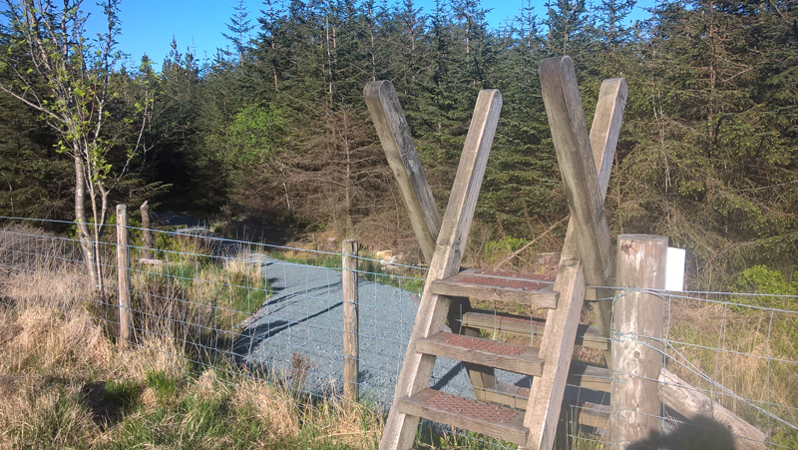
To receive your badge and certificate please email names of walkers, date of walk, time for the following coordinates (below) as well as a jpeg image as evidence to:
info@markpearson.info
Cost of badge and certificate will be £6 per person including p&p, details regarding payment process on application.
Coordinates:
Barmouth (start/finish) GR 612 158
Diffwys GR 661 234
Y Llethyr GR 661 257
Rhinog Fach GR 664 270
Forest Commission area entry/exit stile GR 670 290
Rhinog Fawr GR 656 290
Llanbedr, The Victoria Inn (finish/start) GR 585 268
Although under 20 miles, the walk can be a strenuous undertaking, terrain is rugged and the ascents and descents of each mountain require care and reasonable mountain experience as well as good navigation skills, especially in adverse weather conditions. There are no forms of shelter or sources of refreshment on the walk. Mobile phone connection is intermittent. Know your limits.
Essential Equipment:
Walking boots, waterproofs, hat, windproof & warm clothes.
A map and a compass and the ability to use them.
Food, drink, emergency rations.
First aid kit, whistle, torch, sunblock, survival blanket/bivouac.

